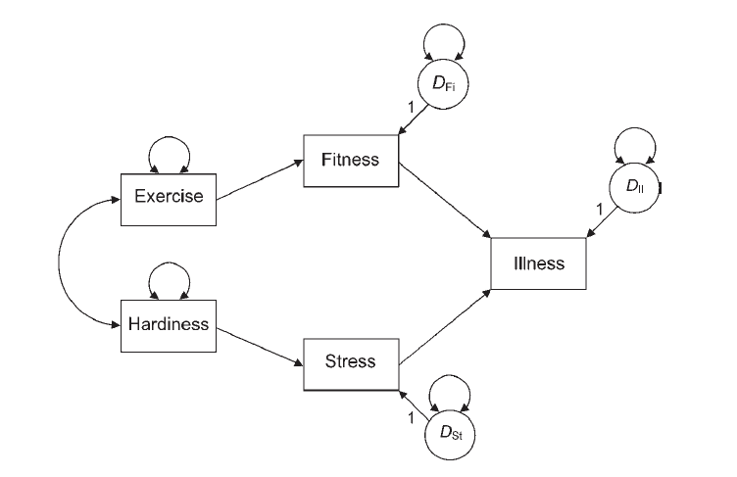

Kline_8_Illness data set.

Create this model in Amos using the dataset provided online.

Cut and paste the model diagram into this word document.

Cut and paste the estimates with Maximum Likelihood.

Edit the model to use a different estimation (ADF, GLS, ULS, SFLS). Cut and paste the estimates for that fitting function.

Are those estimates similar? What about the standard errors? Which function seems to be better for this data?